CRESTLINE VILLAGE WATER DISTRICT
A G E N D A

REGULAR MEETING JULY 19, 2022

The Regular Meeting of the Board of Directors will be held on Tuesday, June 19, 2022 at 3:00 PM, at
the office of the District, located at 777 Cottonwood Drive in Crestline, California, and by teleconference. See below for instructions on how to attend via Zoom.
IMPORTANT NOTICE REGARDING COVID-19 AND TELECONFERENCED MEETINGS:
Based on the mandates by the Governor in Executive Order 33-20 and the County Public Health Officer to shelter in place and the guidance from the CDC, to minimize the spread of the coronavirus, please note the following changes to the District’s ordinary meeting procedures:
- The meeting will be conducted via teleconferencing using Zoom, and in person. As required by the California Department of Public Health, a mask is required for all indoor public settings regardless of vaccination status.
- All members of the public seeking to observe and/or to address the local legislative body may participate in the meeting telephonically or otherwise electronically in the manner described below.
HOW TO OBSERVE THE MEETING:
Telephone: Listen to the meeting live by calling Zoom at 1+(253) 215-8782 or 1+(301) 715-8592
Enter the Meeting ID# 868 6324 2627 followed by the pound (#) key. Passcode: 501498
More phone numbers can be found on Zoom’s website at https://zoom.us if the line is busy.
Computer: Watch the live streaming of the meeting from a computer navigating to
https://us02web.zoom.us/j/86863242627?pwd=NzRQVktUL0ZXb2JtTjNUcEkxTmJGdz09 using a computer with internet access that meets Zoom’s system requirements(see https://support.zoom.us/hc/en-us/articles/201362023-System-Requirements-for-PC-Mac-and-Linux) Mobile: Log in through Zoom mobile app on a smart phone and enter Meeting ID: 868 6324 2627 Passcode: 501498
https://us02web.zoom.us/s/85320904606?pwd=OW10V2N4eTlHRVFtNCtHek9kV01rQT09#success
HOW TO SUBMIT PUBLIC COMMENTS:
Telephonic/Electronic Comments: During the meeting, the Board President or designee will announce the opportunity to make public comments about general items (not listed on the agenda). This will be an opportunity for the public to make comments to the Board during real time. The Board also offers the public the opportunity to provide real time comments on each agenda item before action is taken, and the Board shall allow a reasonable amount of time per agenda item to allow public members the opportunity to provide public comment.

ACCESSIBILITY INFORMATION:
Board Meetings are accessible to people with disabilities and others who need assistance. Individuals who need special assistance or a disability-related modification or accommodation (including auxiliary aids or services) to observe and/or participate in this meeting and access meeting-related materials should contact the District before the meeting at (909) 3381727. Advanced notification will enable the District to swiftly resolve such requests to ensure accessibility.

PUBLIC RECORDS:

Public records that relate to any item on the open session agenda for a meeting are available for public inspection. Those records that are distributed after the agenda posting deadline for the meeting are available for public inspection at the same time they are distributed to all or a majority of the members of the Board. The Board has designated the District’s website located at http://cvwater.com/AGENDA.htm as the place for making those public records available for inspection. The documents may also be obtained by calling the District.

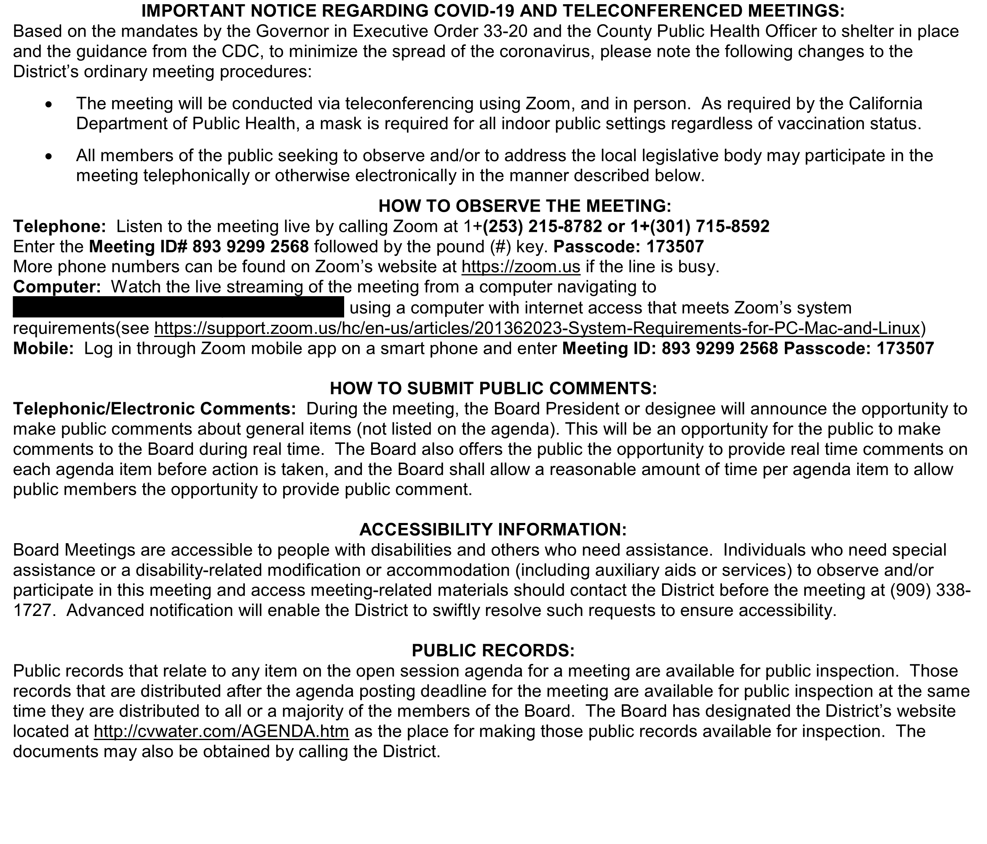

CRESTLINE VILLAGE WATER DISTRICT
A G E N D A

REGULAR MEETING

July 19, 2022
A Regular Meeting of the Board of Directors will be held on Tuesday, July 19, 2022 at 3:00 PM, at the office of the District, located at 777 Cottonwood Drive in Crestline, California.
CALL TO ORDER AND FLAG SALUTE:
TELECONFERENCE MEETING ATTENDANCE: Consider continuation of permitting attendance at District Board meetings via teleconferencing (Required findings: 1. The Board of Directors has reconsidered the circumstances of the state of emergency AND 2. The state of emergency continues to directly impact the ability of the Board, staff and members to meet safely in person OR State or local officials continue to impose or recommend measures to promote social distancing) *
APPROVAL OF MINUTES: June 21, 2022. *
APPROVAL OF CASH DISBURSEMENTS: June 2022 *
PUBLIC COMMENTS:
REGULAR SESSION:
- Discuss Candidate Filing for November 8, 2022 General Election
- Consider CSDA Board Member Best Practices Workshop.
- Consider Attendance at the CSDA Conference August 22-25, 2022. *
- Consider Attendance at the SDLA Conference September 18-21, 2022 *
- Streamline Platform - Subscription Agreement Discussion *
MANAGER’S REPORT:
- Update on District Projects.
- Monthly Financial and Investment Reports.
- Monthly Water Production Reports.
DIRECTORS’ REPORTS:
- Director’s Report.
- Requests for Future Agenda Items.
EXECUTIVE SESSION:
1. PUBLIC EMPLOYEE PERFORMANCE EVALUATION
Pursuant to Government Code Section 54957(b)
Title: General Manager
NEXT SCHEDULED BOARD MEETING: Tuesday, August 16, 2022 at 3:00 PM.
* Planned Board Action. The Board of Directors may take action on any agenda item.

